Q1. Implement an OpenMP program to determine and display the total number of threads participating in a parallel region using the omp_get_num_threads() runtime function.
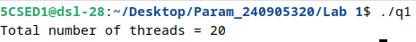
Q2. Implement an OpenMP program that creates a user-specified number of threads using the omp_set_num_threads() runtime function and displays the Thread ID of each thread.
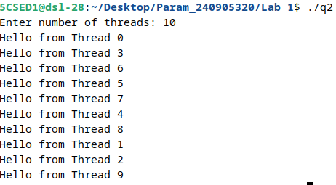
Q3. Implement an OpenMP program to initialize all elements of a 5 × 5 matrix with consecutive integers inside a parallel region using the parallel directive. Display the initialized matrix and print the Thread ID responsible for initializing each row.
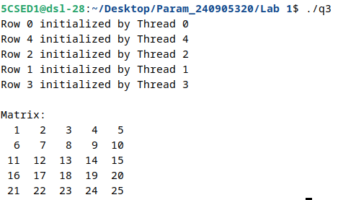
Q4. Implement an OpenMP program to perform the addition of two one-dimensional arrays of size N using the parallel for directive. Display the resulting array and identify the Thread ID that computes each array element.

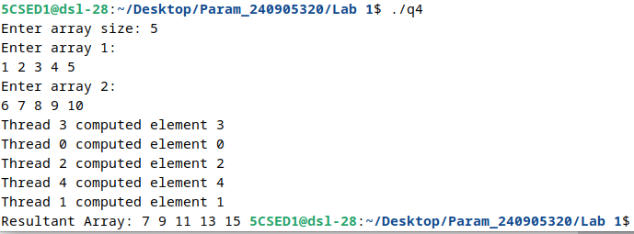

Q5. Implement an OpenMP program to perform the addition of two matrices of size M×N using the parallel for directive. Display the resultant matrix and indicate the Thread ID responsible for computing each row (or element) of the result
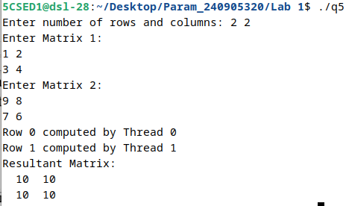
6. Implement an OpenMP program to compute the sum of elements of a large array in parallel using the parallel for directive. Measure and display the execution time of the parallel
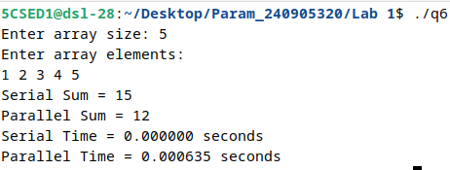
program using the omp_get_wtime() runtime function and compare it with the corresponding serial implementation.

